# Project Design Phase-I Solution Architecture

|  |  |
| --- | --- |
| Date | 06 November 2022 |
| Team ID | PNT2022TMID16380 |
| Project Name | News Tracker Application |
| Maximum Marks | 4 Marks |

**Solution Architecture:**

Solution structure is a complex procedure, with many sub-techniques that the distance between commercial enterprise troubles and era answers. Its dreams are to:

* Find the best tech solution to solve existing business problems.
* Describe the structure, characteristics, behavior, and other aspects of the software to project stakeholders.
* Define capabilities, and development levels, and answer requirements to the task.
* Provide specifications according to which the solution is defined, managed, and delivered to the customers.

# Example - Solution Architecture Diagram:

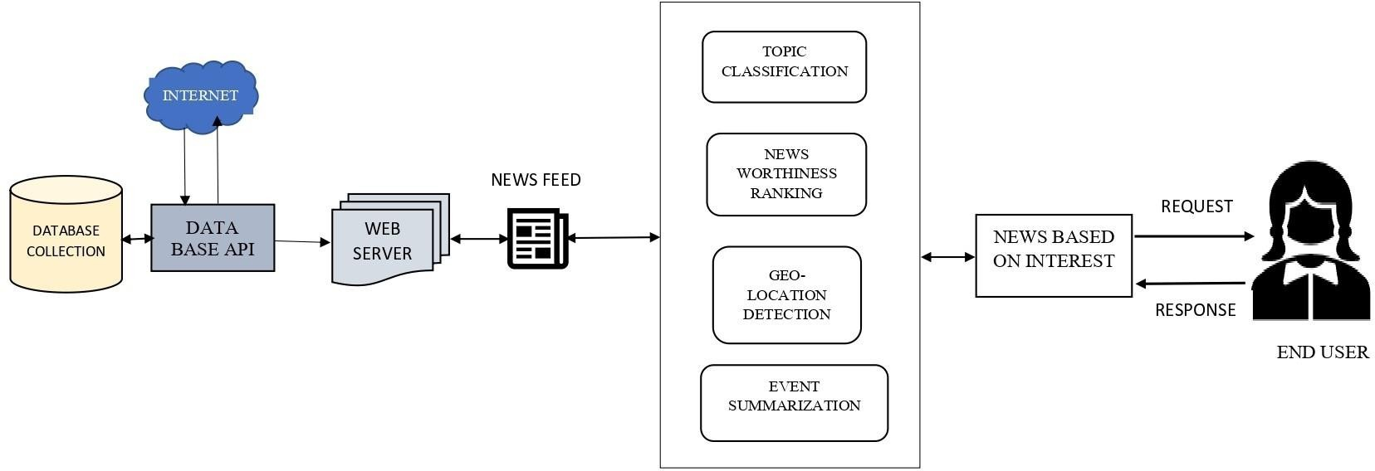

NEWS TRACKER APPLICATION